**Automate a Web Application**

**Project Objective:**

As a Full Stack Developer, you have to build an automation script that automated the basic functionalities like registration and login.

As the project is in the final stage, management has asked you to automate the basic functionalities like registration and login for all the internal employees. This will help the development and DevOps team to work efficiently with the application.

**Projects Requirements:-**

● Eclipse  
● Selenium WebDriver  
● GitHub

**Following requirements should be met:**

● A few of the source code should be tracked on GitHub repositories. You need to document the tracked files that are ignored during the final push to the GitHub repository.  
● The submission of your GitHub repository link is mandatory. In order to track your task, you need to share the link of the repository in the document.  
● The step-by-step process involved in completing this task should be documented.

**Screenshots:-**

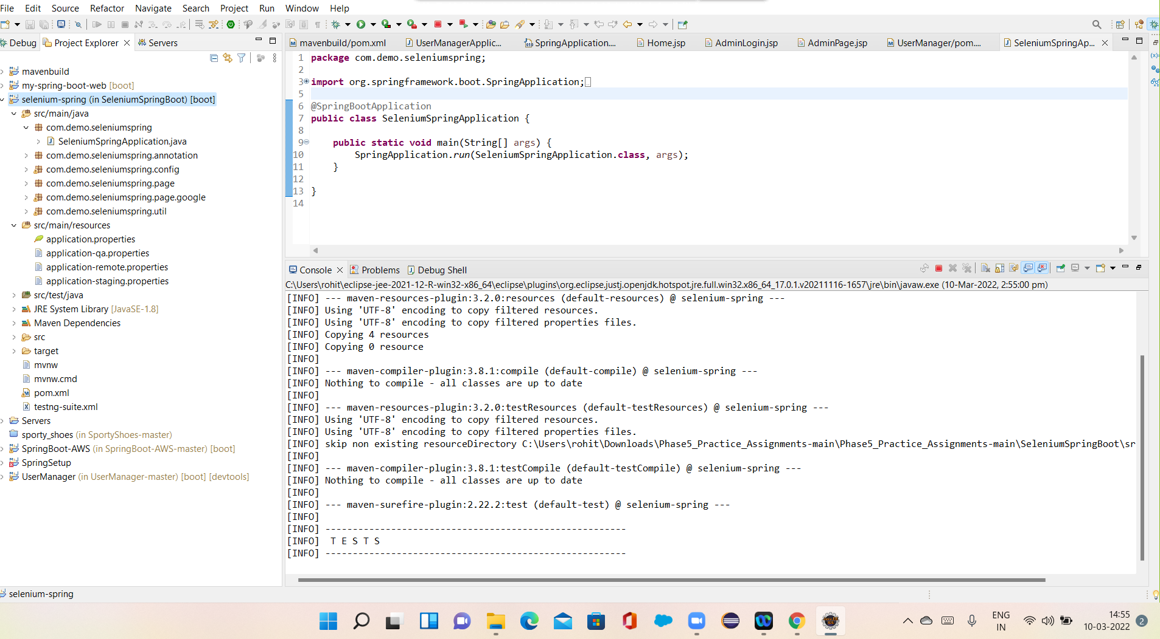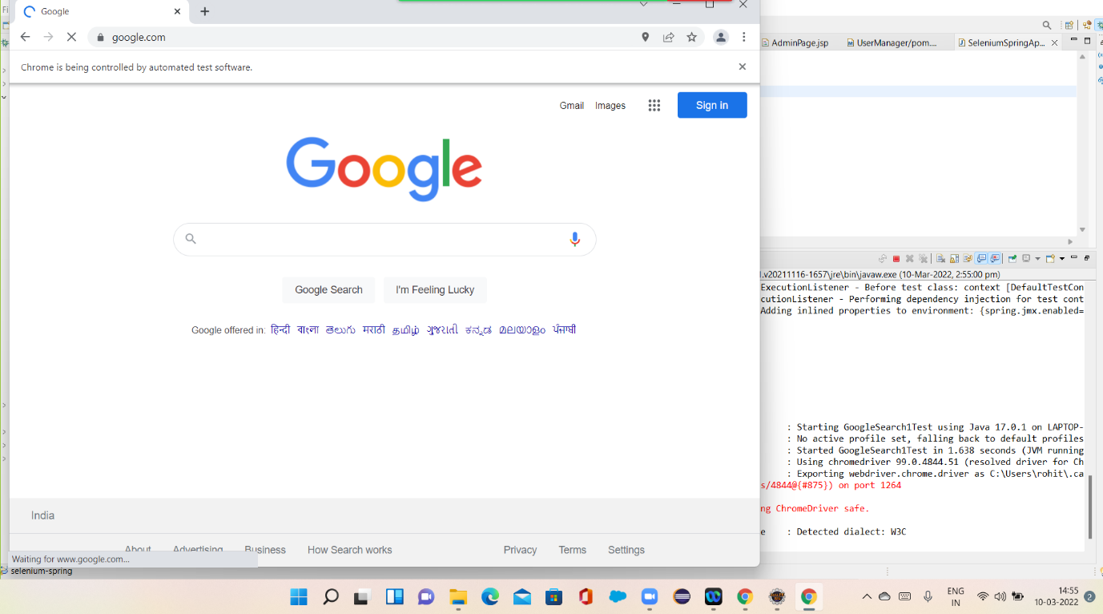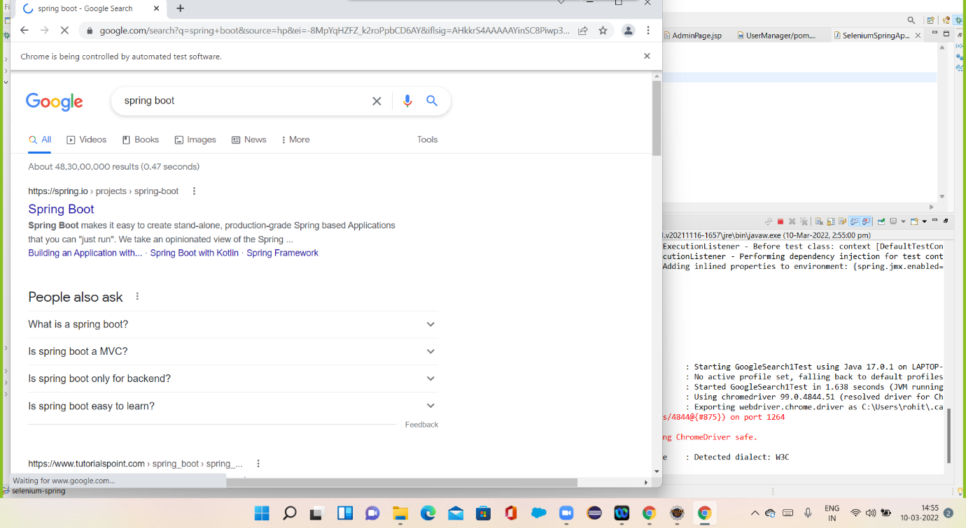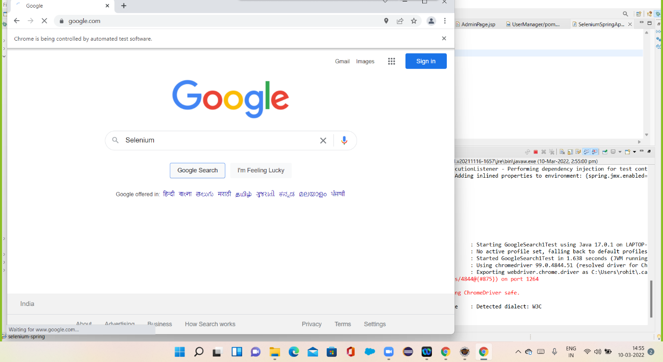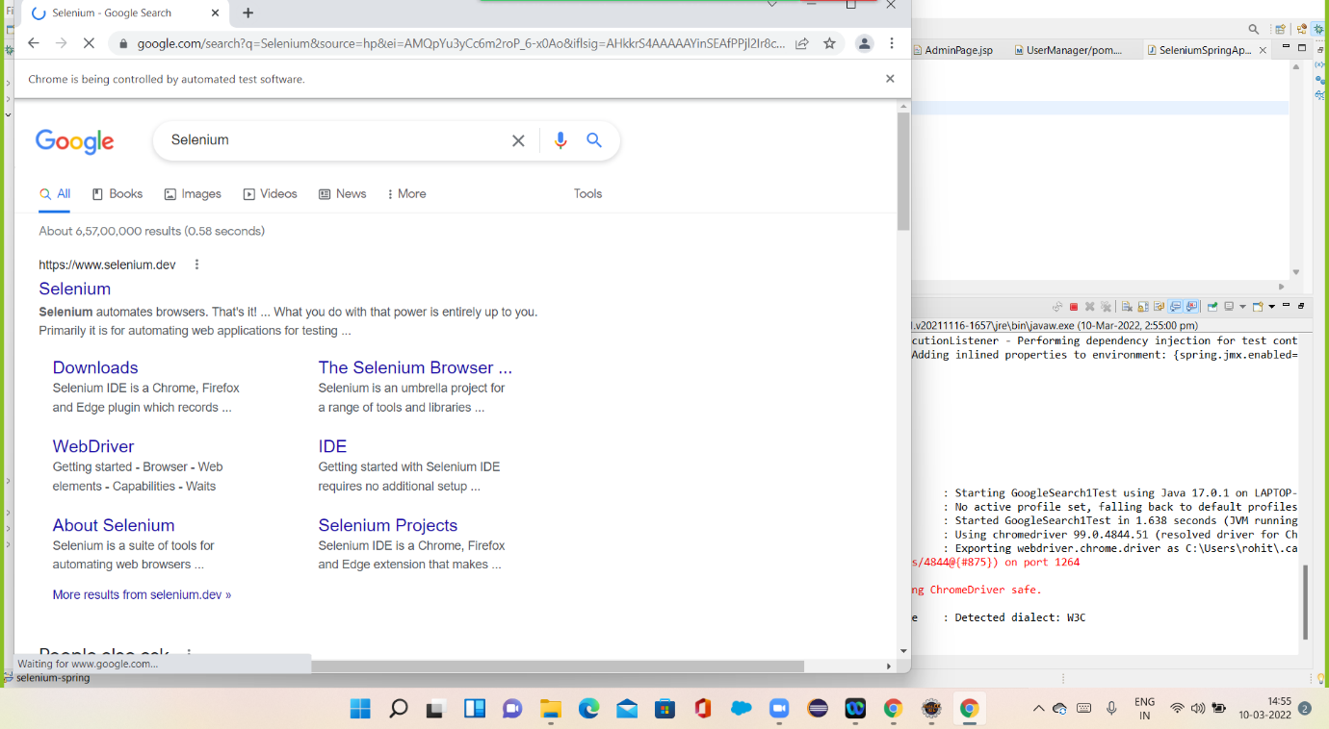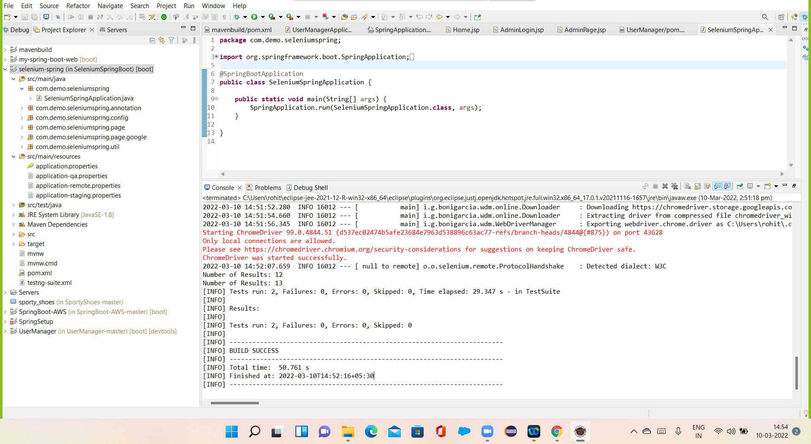

## **Pushing the code to GitHub repository:-**

* Open your command prompt and navigate to the folder where you have created your files.

**cd <folder path>**

* Initialize repository using the following command:

**git init**

* Add all the files to your git repository using the following command:

**git add .**

* Commit the changes using the following command:

**git commit . -m <commit message>**

* Push the files to the folder you initially created using the following command:

**git push -u origin master**